WBSA Sp
Summer Camps 2023

Registration form

Monday –Thursday
5:30-8:30 pm
Field TBD
(Circle the weeks) June 12-15, 19-22, 26-29
July 3-7(4th off), 10-14, 31-aug.-3
August 7-10, 14-17
Boys / Girls U8- U 18
Registration fee: $15
Cost of the camp: $115 per week( more than 1 week, $100 each)

T shirt cost: $15 size YS ( ) YM( ) YL ( ) AS ( ) AM( ) AL( )
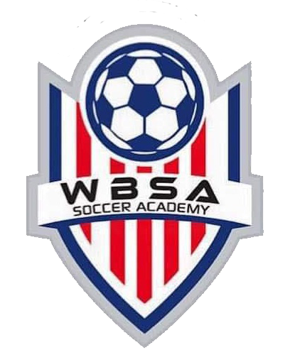

Name: Age: Address: state: zip: Home#:
Cell#:
DOB: / /
Emergency Contact :

Phone#:

Waiver and Release
I, the guardian/parent of ,understand that there are certain risks of injury or COVID 19 contagious inherent in the practice and play of this sport or activity, and I am willing to assume these risks. In addition of giving my full consent for my child participation, I do hereby waive, release and hold harmless the WBSA, COSALVA, its officers, Manassas park community center , coaches, sponsors, supervisors and representatives for any injury that my child may be suffered by participation in the designated sport or activity and the activities incidental thereto, whether the result of negligence or any other cause.
Signature: Date (Parent/ guardian signature)

WBSA Summer Camps 2023
www.wbsocceracademy.org

